**Create the below tables with appropriate data types and constraints. Then Solve the queries.**

**Note : The queries and its output needs to be saved and pushed to the git link**

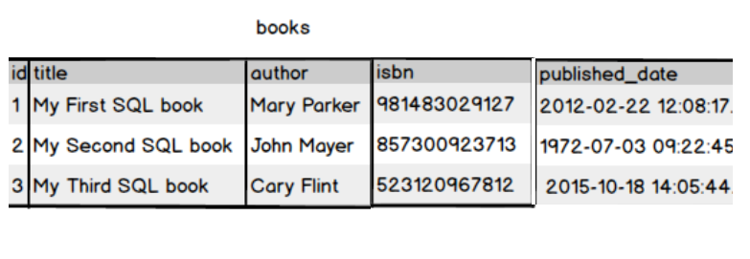

Create a book table with id as primary key and provide the appropriate data type to other attributes .isbn no should be unique for each book

Write a query to fetch the details of the books written by author whose name ends with er.



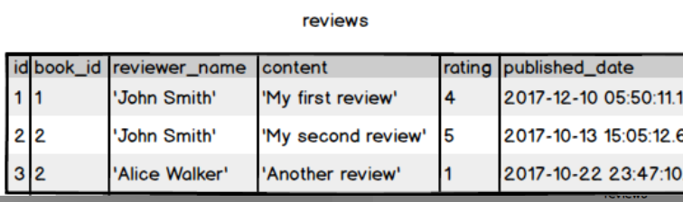

Display the Title ,Author and ReviewerName for all the books from the above table





.

1. Display the reviewer name who reviewed more than one book

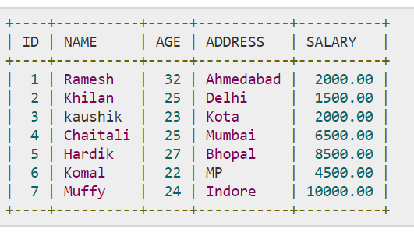

Display the Name for the customer from above customer table who live in same address which has character o anywhere in address

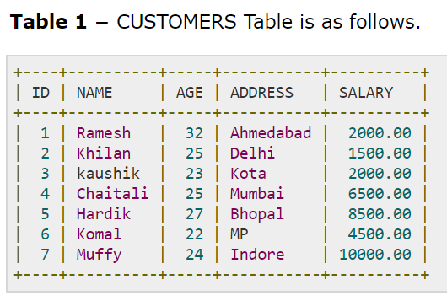 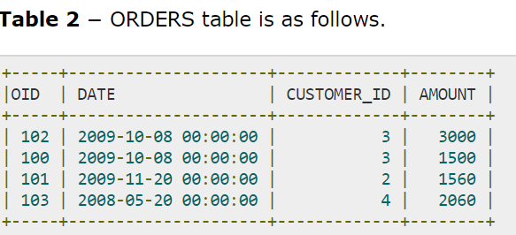

Write a query to display the Date,Total no of customer placed order on same Date

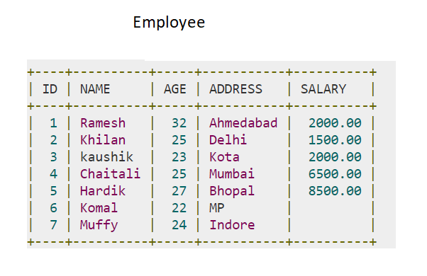

Display the Names of the Employee in lower case, whose salary is null

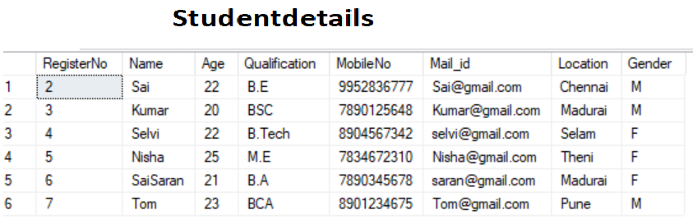

Write a sql server query to display the Gender,Total no of male and female from the above

relation .

Query and outputs:

1.---Q1)Write a query to fetch the details of the books written by author whose name ends with er.

select*from books where author like '%er'

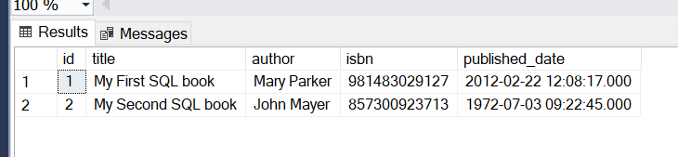

---Q2) Display the Title ,Author and ReviewerName for all the books from the above table

SELECT b.title, b.author, r.reviewer_name

FROM books AS b

INNER JOIN reviews AS r ON b.id = r.book_id;

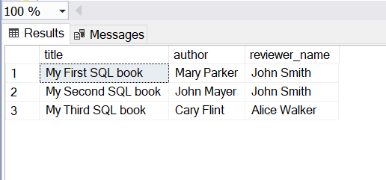

--Q3) Display the reviewer name who reviewed more than one book

SELECT reviewer_name

FROM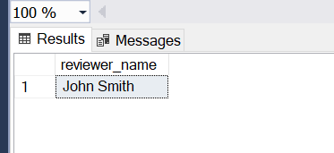 reviews

GROUP BY reviewer_name

HAVING COUNT(DISTINCT book_id) > 1;

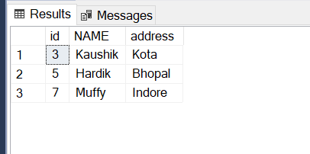---Q4) Display the Name for the customer from above customer table who live in same address which has character o anywhere in address

SELECT id,NAME,address

FROM employee

WHERE ADDRESS LIKE '%o%'

---Q5 Write a query to display the Date,Total no of customer placed order on same Date

SELECT DATE, COUNT(DISTINCT CUSTOMER_ID) AS TotalCustomers

FROM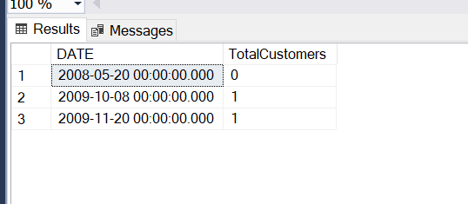 ORDERS

GROUP BY DATE

ORDER BY DATE;

---Q6) Display the Names of the Employee in lower case, whose salary is null

SELECT LOWER(Name) AS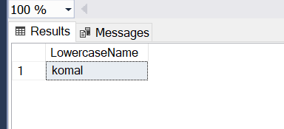 LowercaseName

FROM Employee

WHERE Salary IS NULL;

## Ma,am i have given only komal as Null

---Q7) Write a sql server query to display the Gender,Total no of male and female from the above relation .

SELECT Gender,

COUNT(*) AS TotalNo

FROM Studentdetails

GROUP BY Gender;

##I have given 3 female and 3 male in the table

